***Database Management System***

***Project Report***

**Project name: Airline Ticket Management System**

**Objective:**

To build a DBMS using majority of the concepts and syntax learned throughout the semester and then, to fill that system with dummy values to test it.

Below is the ERD of our DBMS:

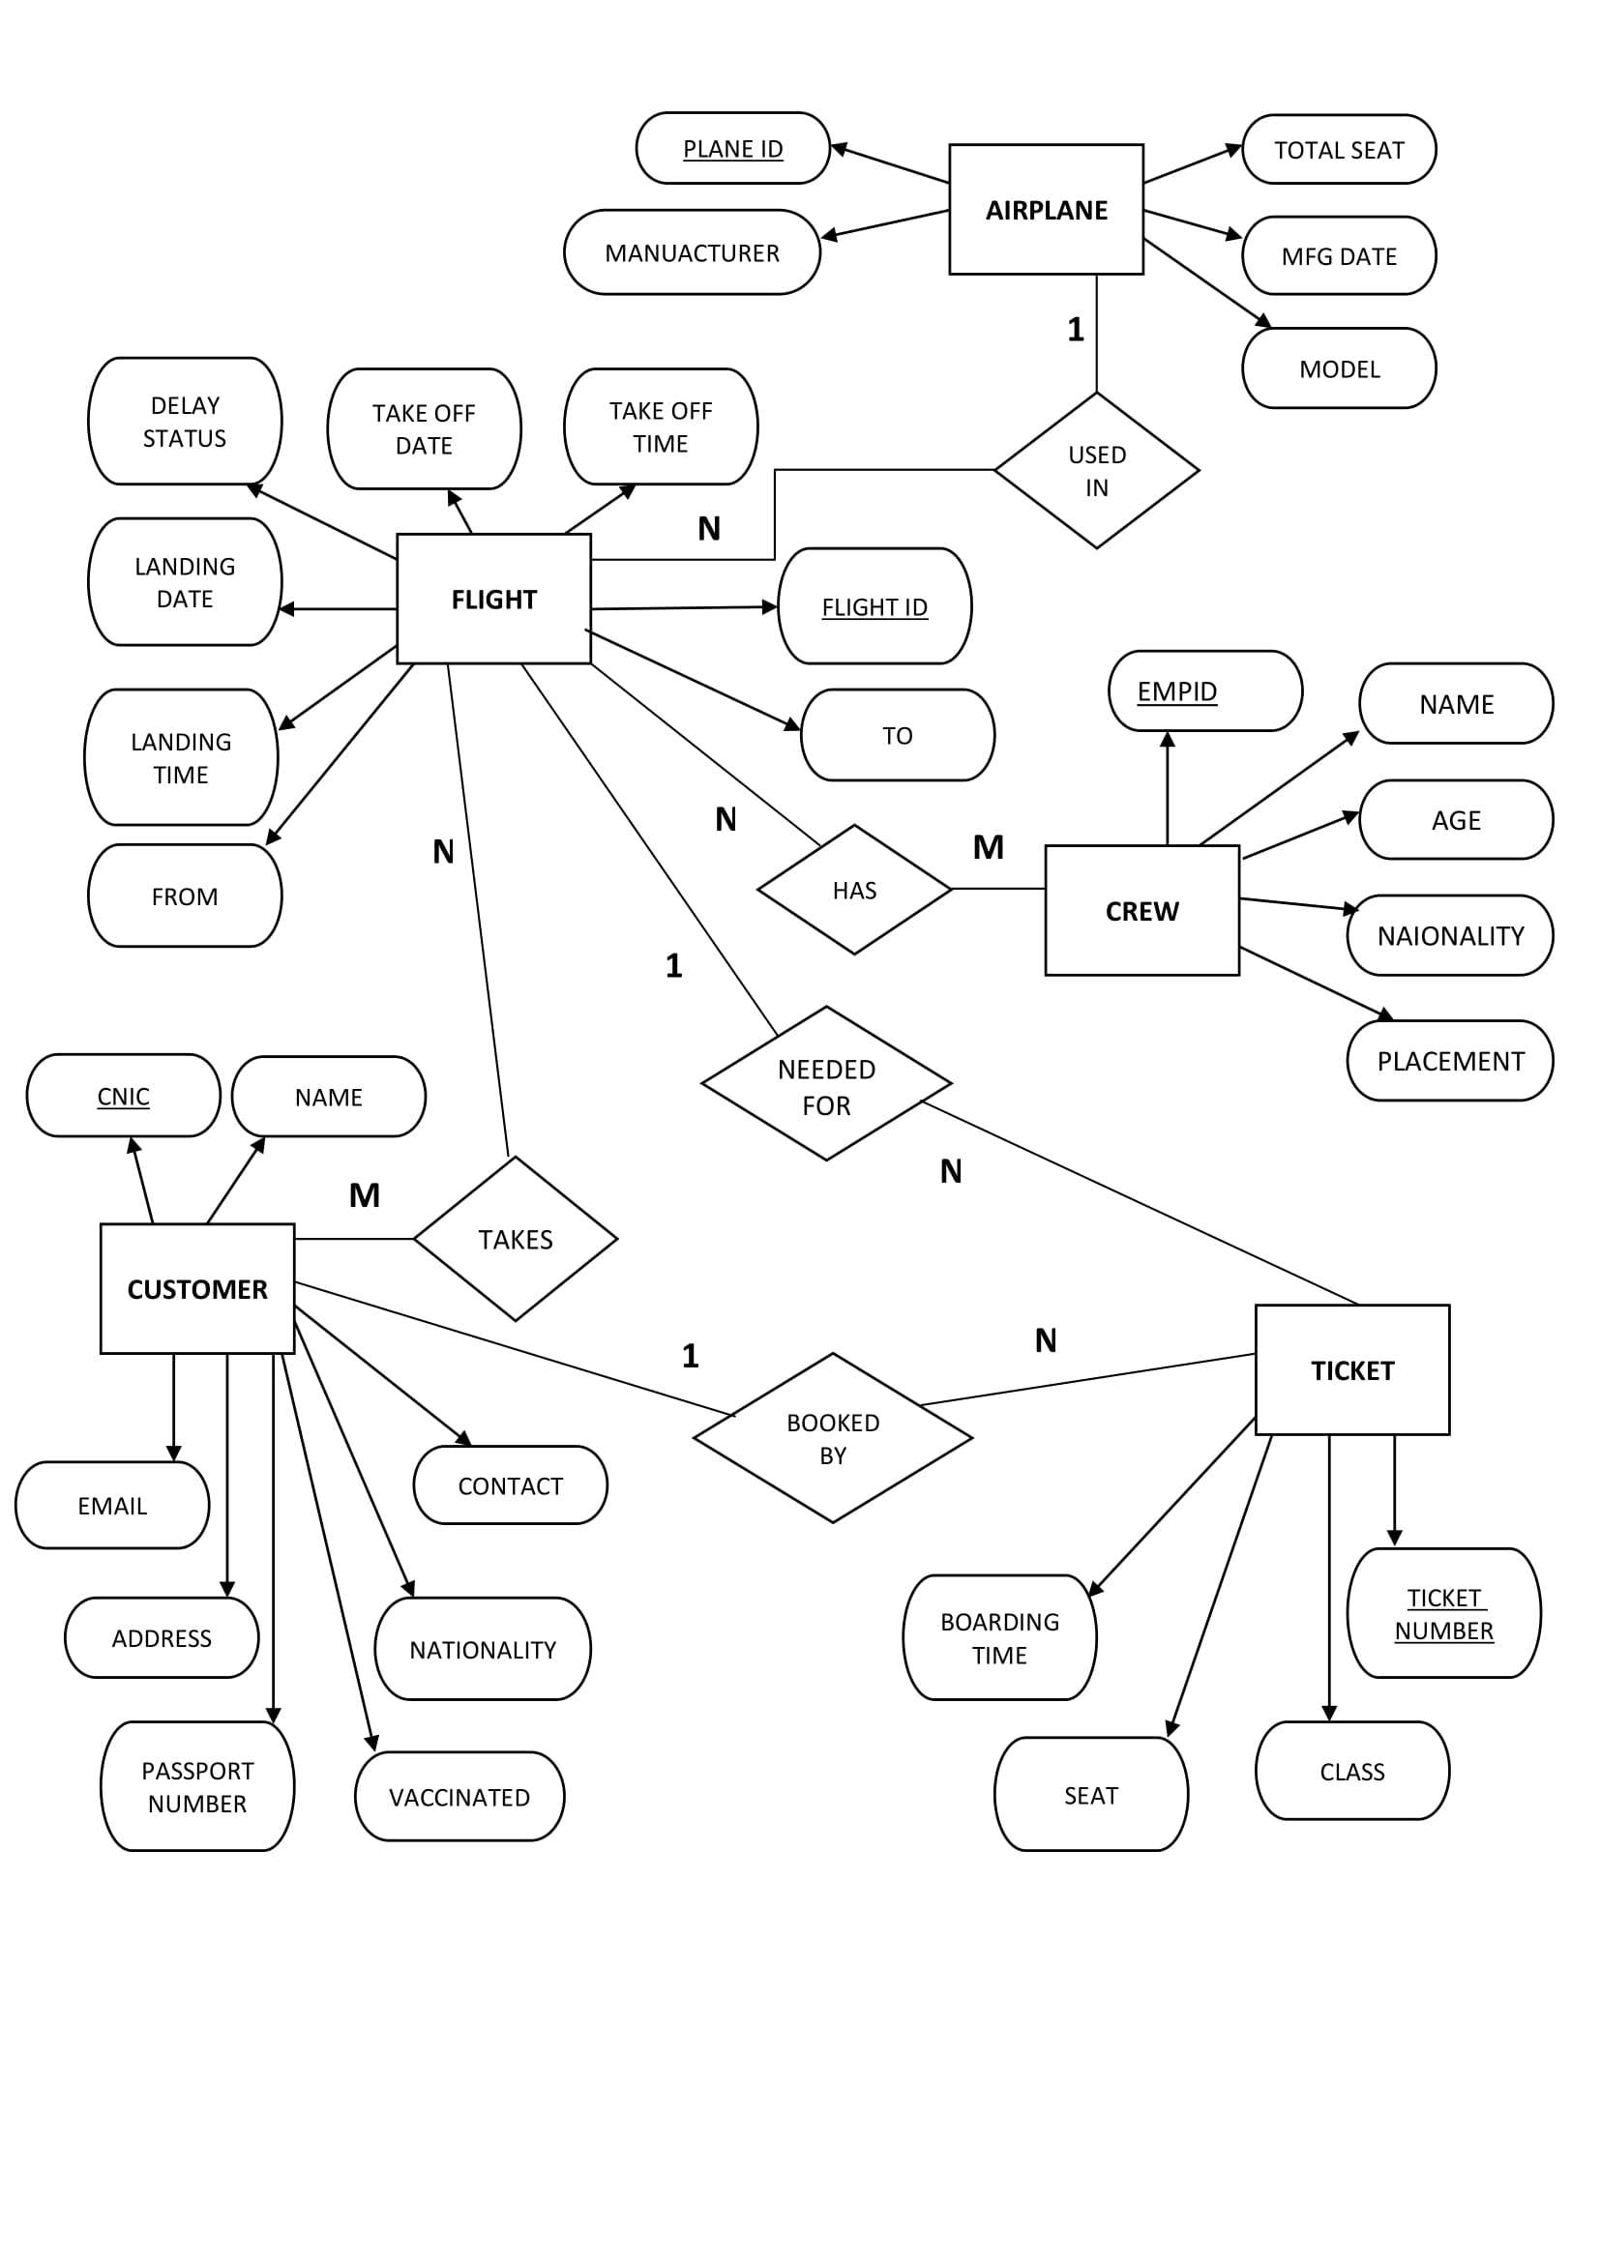

**Tables:**

There are a total of 5 tables and 2 relational tables in our database:

1. Airplane
2. Flight
3. Crew
4. Customer
5. Ticket
6. Flight_has_crew
7. Customer_takes_flight

Following is the cardinality of the relationships between the tables:

* Airplane 1 : N Flight
* Flight N : M Crew
* Flight 1 : N Ticket
* Flight N : M Customer
* Customer 1 : M Ticket

As the Flight-Crew and Flight-Customer relationships have a Many-to-Many relationship, the relational tables **flight_has_crew** and **customer_takes_flight** have been created to establish the relationship.

Following is what all these tables look like (dummy values have been added for testing):

**Airplane table:**

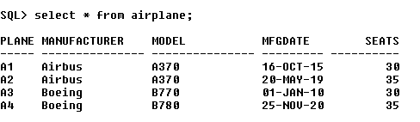

**Flight table:**

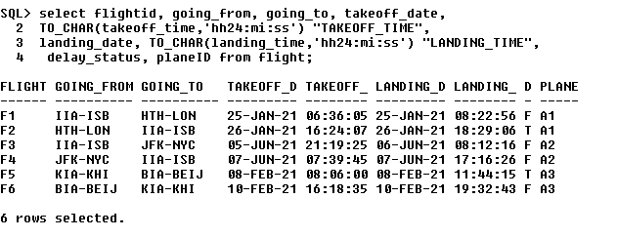

**Crew table:**

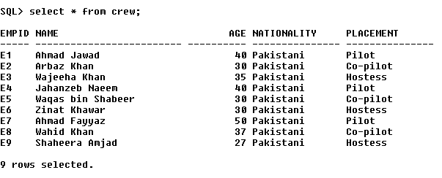

**Customer table:**

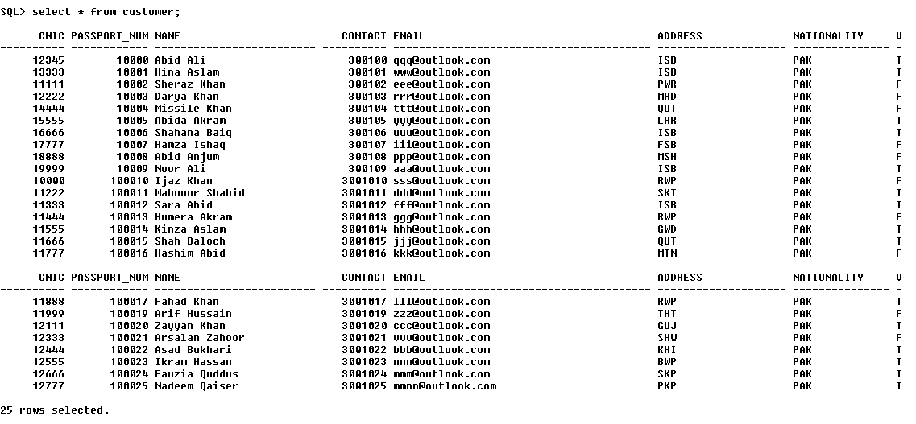

**Customer_takes_flight table:**

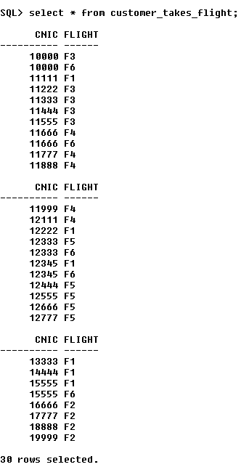

**Flight_has_crew table:**

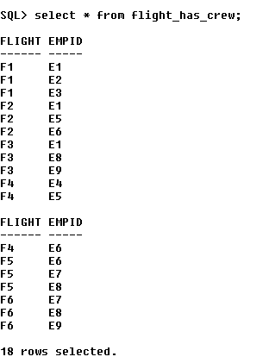

**Ticket table:**

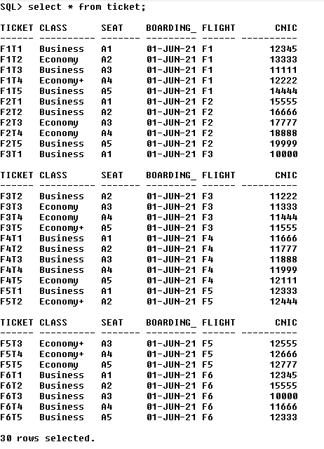

Here are some of the joins statements that we have run on these tables:

**1.**

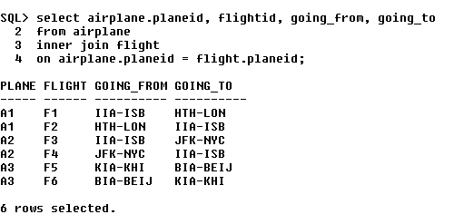

This join statement show all the airplanes that were used in flights, their flight ID and from where to where these flights were going.

**2.**

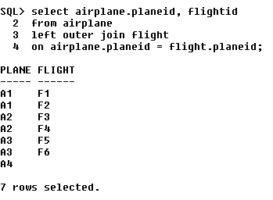

This join statement shows all the data in the airplane table and the corresponding values in the flight table. (For those rows where corresponding value was not available, the system added null)

**3.**

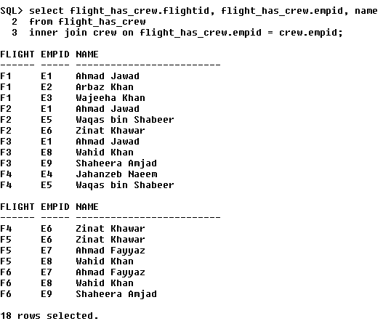

This join statement shows all the flight IDs, and IDs and names of employees who were on these flights.

**4.**

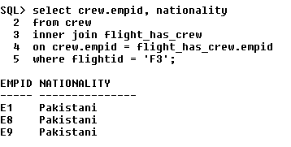

This join statement shows the nationality of the employees on a particular flight.

**5.**

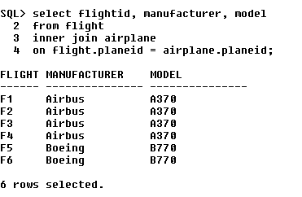

This join statement shows which plane model was used to each flight and who manufactured that plane.

**6.**

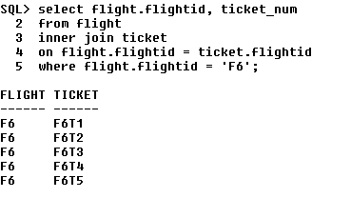

This join statement shows all the ticket numbers of passengers on a particular flight.

**7.**

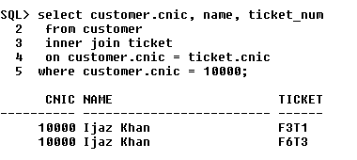

This join statement shows the cnic, name and ticket numbers of all the ticket bought by a particular customer.

**8.**

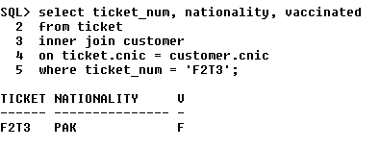

This join statement shows the nationality and vaccination status of a customer with particular ticket number.

**9.**

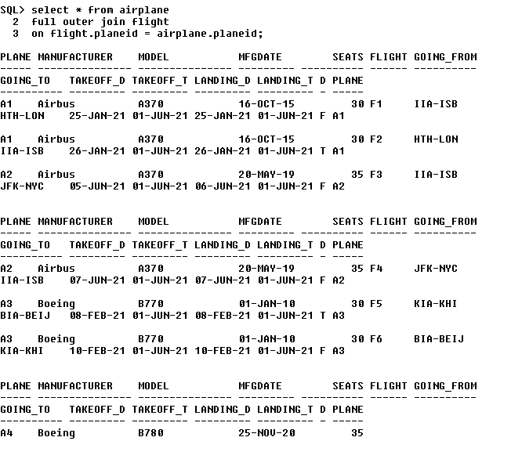

This join statement shows all the data in the airplane and flight tables. The records for which corresponding data values were not available, null has been added by the system.

**10.**

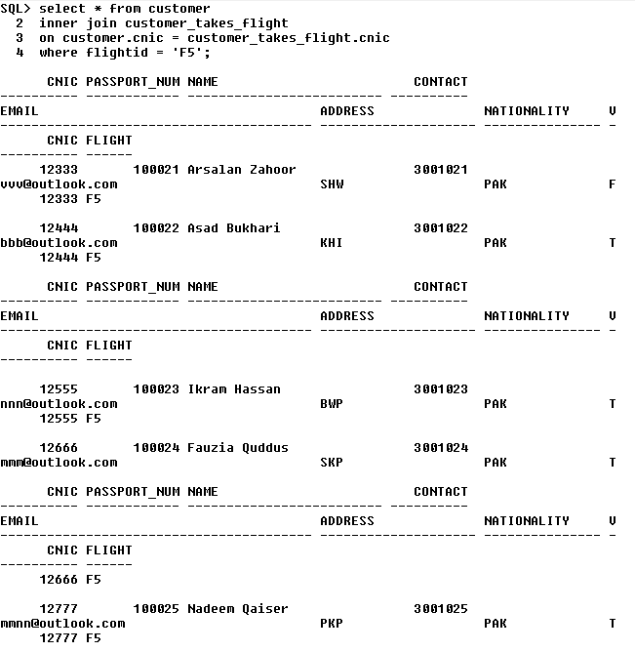

This join statement shows all the customer details of the passengers on a particular flight.

**Conclusion:**

It can be seen that it is indeed possible build said DBMS using the concepts learned throughout the semester.